**Chapter I**

**INTRODUCTION**

**Project Context**

Design and Evaluation of an advance learning mobile application for Mathematics describes an academic need in a student who is learning beyond grade level in one or more context areas and who’s learning needs on those area fall outside the need of most of the students in their classroom. Advance learning provides high quality interactive multimedia context development.

GuershonHarel and Larry Sowder (2001) stated that advanced mathematical thinking usually conceived as thinking in advanced Mathematics, might profitably be viewed as advanced thinking in mathematics. Hence, advance mathematical-thinking can properly be viewed as potentially starting in elementary school. The definition of mathematical thinking entails considering the epistemological and didactical obstacles to a particular way of thinking.

Leongson (2003) reveals that Pilipino students excel in knowledge acquisition but fare considerably low in lessons requiring higher order thinking skills. This disappointing condition is evident in the performance of students in national and international surveys on Mathematics competencies. (http://www.research.acer.edu.au.cgi.veiwcontent.cgi)

Normally we see that students have a fear towards the subject Mathematics. They are unable to understand the basic concepts of Mathematics and their technique due to various reasons. The problems that occur in the process of learning Mathematics are relatively less in case of other subjects. Hence, for common students mathematics becomes a tougher subject and consequently, they try to avoid it.

For these reasons, the proponents gained their deepest desire to design and develop an advance learning mobile application in Mathematics for elementary pupils, which is the main goal is to help the students make connections between conceptual and procedural knowledge through mobile application. Through this application the students can easily access their topics from grade 1 to grade 6. They can review their previous topics without searching for different books in all grade level. It will help the student learn better and it will serve as an aid for those who are doesn’t like mathematics. With this Advance learning mobile application for the students in elementary as well as the teachers will be both benefited on this application so called advance learning mobile application for Mathematics.

**Purpose and Description**

This portion contains the benefits of the user to the system and similarly explains what it can provide to the students. This study will provide tangible and intangible benefits to the following entities:

*Teachers.* Through the mobile application, the teacher can have an efficient, less hassle and interactive lessons of information for the students. It will also fulfill the student’s needs and satisfaction.

*Elementary pupil.*They can easily access all the feature of advance learning mobile application. The pupils will enjoy the different games by grade level.

*Parents.* Parents can teach their children using this application and see the progress of their child.

*Future researchers*. This study also can help to the future researcher for the additional information related to advance learning for mathematics in elementary pupils using mobile application. This website may serve as their reference.

**Objectives of the Study**

The main objective of this study was to design and develop an advance learning application of Mathematics for elementary pupils and teachers, specifically;

1. Design and develop advance learning mobile application of Mathematics for elementary pupils in terms of:

1.1. Elementary Mathematics from grade 1 to grade 6;

1.2. User accounts;

1.3. Games / Quizzes;

2. Provide opportunities for learners to deal with the subject outside the classroom.

3. Able to develop an application that has a capable of:

3.1 Viewing of grade level topics;

3.1.1 Counting

3.1.2 Addition

3.1.3 Subtraction

3.1.4 Division

3.1.5 Numbers

3.1.6 Pre-Algebra

3.1.7 Geometry

3.1.8 Geometry (Plane)

3.1.9 Geometry (Solid)

3.1.10 Data

3.1.11 Estimation

3.1.12 Probability

3.1.13 Measurement

3.1.14 Time

3.1.15 Money

3.1.16 Multiplication

3.1.17 Decimals

3.1.18 Fraction

3.1.19 Percentage

3.1.20 Ratio

3.1.21 Exponents

3.1.22 Linear Equations

3.1.23 Graphs

3.1.24 Probability

4. Determine the strength and weaknesses of the student using progress bar.

5. Enable to evaluate the Advance Learning mobile application in Mathematics

**Scope and Delimitation of the Study**

This section presents the scope and delimitation of the study.

The proponents gained their deepest desire to design and develop an advance learning mobile application of Mathematics for elementary pupils, which is the main goal is to help the students make connections between conceptual and procedural knowledge through mobile application. Through this application the students can easily access their topics from grade 1 to grade 6. They can review their previous topics without searching for different books in all grade level. It will help the student learn better and it will serve as an aid for those who are doesn’t like Mathematics. With this Advance learning mobile application for the students in elementary as well as the teachers will be both benefited on this application so called advance learning mobile application for Mathematics.

The users can only access the application using android mobile phone. The application is exclusive only for authorized or registered user. It has two categories; the topics from grade 1 to grade 6 and games.

**Conceptual Framework**

The conceptual framework of the study, it dissects the inputs, processes, and the expected result of the study, during the designing of the Advance learning mobile application of Mathematics in elementary pupils. The proponents will give direction to the study and able to solve its problems. Aside from presenting direction of the study, through this conceptual framework, the researcher can show the relationships of the different constructs to investigate.

In the first stage, which is the input stage, all knowledge, software, and hardware requirements were gathered. In order to go to the next stage, which is the process stage these requirements were needed. In knowledge requirements, the datagathered from teachers and students in order to formulate the entities that are included in the study. After gathering the data, the proponents choose the right programming software like Unity, SQLite and C# to start programming the system with less complexity. Hardware is also important specially laptops because its handy.

In the process stage, proponents started analyzing the data from the input stage, coding the design and functionality of the system. Then after that, the system runs into multiple testing and debugging methods to measure the quality before its implemented and evaluated.

The last stage, which is the output, presents the product of the study, the Advance Learning application on Mathematics in Elementary pupil.

**INPUT PROCESS OUTPUT**

Knowledge Requirements:

* Elementary Mathematics from grade 1 to grade 6

Software Requirements:

* UNITY
* C#
* SQLite

Hardware Requirements:

* Laptop/PC
* Planning
* System Analysis
* Requirements Determination
* System Design
* System Building
* System Testing & Debugging
* System Implementation
* System Evaluation

Advanced Learning Application in Mathematics for Elementary Pupils

Figure 1.0 **The Conceptual Framework of the Study**

**Definition of Terms**

Presented below are the terms that need to be defined according to their conceptual and operational purposes for further understanding of the study.

*Android*. A mobile operating system developed by Google, based on the Linux kernel and designed primarily for touchscreen mobile devices such as smarthphones and tablets. Android’s user interface is mainly based on direct manipulation, using touch gestures that loosely correspond to real-world actions, such as swiping, tapping and pinching, to manipulate on-screen objects, along with a virtual keyboard for text input.

*Advanced Learning.* Describes an academic need in a student who is learning beyond grade level in one or more context areas and who’s learning needs on those area fall outside the need of most of the students in their classroom.

*C#.* Multi-paradigm programming language encompassing storing typing, imperative, declarative, functional, generic, object-oriented (class-based), and component-oriented programming disciplines. The language is intended for use in developing software components suitable for development in distributed environments.

*Database.* An organize data collection for one or more purposes, usually in digital form.

*Evaluation.*A systematic and objective assessment of an ongoing or completed project, programmed or policy, its design, implementation and result. The aim is to determine the relevance and fulfillment of objectives, efficiency, effectiveness, impact and sustainability – as set out in the evaluation policy.

*Mathematics.* The study of topics such as quantity (numbers), structure, space, and change.

*Mobile Application*.A software application developed specifically for use on small, wireless computing devices, such as [smartphones](http://searchmobilecomputing.techtarget.com/definition/smartphone) and [tablets](http://searchmobilecomputing.techtarget.com/definition/tablet-PC), rather than desktop or laptop computers.

*Programming.* Refers to the process of designing, writing, testing, debugging, and maintaining the source code of computer programs.

*Software development kit (SDK).* A set of software development tools that allows the creation of applications for a certain of applications for a certain software package, software framework, hardware platform, computer system, video game console, operating system, or similar development platform.

*SQLite*. A relational database management system contained in a C programming Library. In contrast to many other database management systems, SQLite is not a [client–server](https://en.wikipedia.org/wiki/Client%E2%80%93server) database engine. Rather, it is embedded into the end program. SQLite is [ACID](https://en.wikipedia.org/wiki/ACID)-compliant and implements most of the [SQL](https://en.wikipedia.org/wiki/SQL) standard, using a dynamically and weakly [typed](https://en.wikipedia.org/wiki/Data_type) SQL [syntax](https://en.wikipedia.org/wiki/Syntax) that does not guarantee the [domain integrity](https://en.wikipedia.org/wiki/Domain_integrity). SQLite is a popular choice as [embedded database](https://en.wikipedia.org/wiki/Embedded_database) software for local/client storage in [application software](https://en.wikipedia.org/wiki/Application_software) such as [web browsers](https://en.wikipedia.org/wiki/Web_browser). It is arguably the most widely deployed [database engine](https://en.wikipedia.org/wiki/Database_engine), as it is used today by several widespread browsers, [operating systems](https://en.wikipedia.org/wiki/Operating_system), and [embedded systems](https://en.wikipedia.org/wiki/Embedded_system) (such as mobile phones), among others. SQLite has [bindings](https://en.wikipedia.org/wiki/Language_binding) to many programming languages

*System*. A set of detailed methods procedures and routines to carry out a specific activity, perform a duty, or solve a problem.

*System developmentlife cycle (SDLC).* Also referred to as the application development life-cycle, is a term used in [systems engineering](https://en.wikipedia.org/wiki/Systems_engineering), [information systems](https://en.wikipedia.org/wiki/Information_system) and [software engineering](https://en.wikipedia.org/wiki/Software_engineering) to describe a process for planning, creating, testing, and deploying an [information system](https://en.wikipedia.org/wiki/Information_system). The systems development lifecycle concept applies to a range of hardware and software configurations, as a system can be composed of hardware only, software only, or a combination of both.

*Unity.* A cross-platform game engine developed by Unity Technologies, which is primarily used to develop video games and simulations for computers, consoles and mobile devices.Unity is notable for its ability to target games for multiple platforms.

**Chapter II**

**REVIEW OF RELATED LITERATURES**

This chapter contains the technical background and relevant information in the form of literature and studies taken from sources like school websites, books, journals, internet and thesis from different graduate libraries which serve as a foundation for the current research.

**Technical Background**

Unity is an all purpose game engine that supports 2D and 3D graphics, drag and drop functionality and scripting through C#. Two other programming languages were supported: Boo, which was deprecated with the release of Unity 5 and UnityScript which was deprecated in August 2017 after the release of Uity 2017. The engine targets the following graphics APIs: Direct3D on Windows and Xbox One; OpegGL on Linux, macOS, and Windows; OpenGL ES on Android and iOS; WebGL on the web; and proprietary APIs on the video game consoles. Additionally, Unity supports the low-level APIs Metal on iOS and MacOs and Vulkan on Android, Linux, and Windows, as well as Direct3D 12 on Windows and Xbox One. Within 2D games, Unity allows importation of sprites and an advanced 2D world renderer. For 3D games, Unity allows specification of texture compression and resolution settings for each platform that the game engine supports, and provides support for bump mapping, reflection mapping, parallax mapping, screen space ambient occlusion (SSAO), dynamic shadows using shadow maps, render-to-texture and full-screen post-processing effects. Unity also offers services to developers, these are: Unity Ads, Unity Analytics, Unity Certification, Unity Cloud Build, Unity Everyplay, Unity IAP, Unity Multiplayer, Unity Performance Reporting and Unity Collaborate.

Unity is notable for its ability to target games for multiple platforms. The currently supported platform are Android, Android TV, Facebook Gameroom, Fire OS, Gear VR, Google Cardboard, Google Daydream, HTC Vive, iOS, Linux, macOs, Microsoft HoloLens, Nintendo 3DS family, Nintendo Switch, Oculus Rift, PlayStation 4, PlayStation Vita, PlayStation VR, Samsung Smart TV, Tizen, tvOS, WebGL, Wii U, Windows, Windows Phone, Windows Store, and Xbox One. Unity Web Player was a browser plugin that was supported was browser plugin that was supported in Windows and OS X only, which has been deprecated in favor of WebGL.

Unity is the default software development kit (SDK) for Nintendo’s Wii U video game console platform, with a free copy included by Nintendo with each Wii U developer license. Unity Technologies calls this bundling of a third-party SDK an “industry first”. (https://en.m.wikipedia.org/wiki/Unity_(game_engine))

**Review of Related Studies**

In order for the researchers to have a comprehensive study of the proposed project, the researchers searched via internet, books and other reference tool to furnish the study of the proposed project. These are the following literatures of different authorities which will served as a guide in the research process.

In developing this study, the group referred to the related studies of:

*AdaptedMind***.** Created by graduates of Stanford, Berkeley and Harvard to improve the way children learn. We aspire to bring a revolution to education, improving it by pushing the frontier in learning science. Your child is unique. But the mathbooks and exercises your child does are the same as other children's. AdaptedMind creates a custom learning experience for your child. A learning experience that identifies your child's strengths and weaknesses, and delivers a curriculum and exercises that adapts to these needs. That's adaptive learning.We created our curriculum in consultation with teachers, parents, and most importantly - children. The result is a learning experience that significantly improves performance, guaranteed. (<http://www.adaptedmind.com>)

*Complete Mathematics.* Complete Mathematics App covers basic and high school maths in a simple way. It categorizes different aspects of math in such a way that you can pick up what you plan to learn and start learning.  
Gone are the days when most people complain about learning mathematics. This app has solved the problem. Complete Mathematics App has the following sections tutorials, formulas, calculation, theory questions, quiz, dictionary, scientific calculator, graphing calculator, math tricks, brain teaser, unit converter, binary converter, statistics calculator. This app can be used my any math lover, teachers and students planning to write exam. This app was built around the following examinations WAEC, NECO, GCE, GCSE, KCSE and JAMB syllabus but feel free to use it to solve your own math problems. Although we plan to cover all the topics you can think about, this app will be constantly updated with fresh topics at interval.**(**<https://play.google.com/store/apps>)

*Marble Math.*One of the most fun, customizable, and effective math games available for older elementary school-age kids. Moving the marble around the maze while collecting answers and avoiding obstacles is so absorbing that kids easily forget they're practicing math skills like fractions, decimals, and Roman numerals. As kids solve increasingly difficult math problems and move through challenging mazes, they earn points and new marbles to keep them motivated. Marble Math is an engaging, sticky way for kids to practice math skills.(<https://www.commonsensemedia.org/app-reviews/marble-math>)

*Mathematics***.** Calculate any formula you want and show them in a 2d or 3d plot. The natural display shows fractions, roots and exponents as you would expect it from mathematics. In a few seconds you derivate or integrate your desired function, calculate the zero points of your function und show them in the function plot. See all maxima, minima or inflection points in one view. The easy way of use allows you to solve linear equations in just a moment. Or transform your mathematical, physical or chemical equation to any unknown variable. You often needs to calculate with binary, octal or hexadecimal number systems? No problem! You can mix them together in one calculation even by using decimal digits. But that's not enough! You can also calculate with any other number system with base 2 to 18. From time to time you may need to convert units to another one, like Celsius to Fahrenheit, miles to kilometre, inches to foot and so on. You will also be able to calculate with vectors, matrices and determinants. All this features are combined in this app and will make your mathematical life a lot easier. **(**<https://play.google.com/store/apps>)

*Pocket Mathematics.* is easy to use, free education app that covers most of the vital concepts, equations, and formulas of mathematics. This education application is a must-have guide, whether you want to refresh your knowledge, prepare for an exam, or just refresh the core concepts of mathematics. Pocket Mathematics provides discrete explanations of critical concepts taught in an introductory math course from logic and sets to integrals. It is also a perfect reference, full of formulas, equations, and images for students who need help with math homework assignments.Key features. Contains content focused on key topics only. Each topic contains formulas, equations and detailed description with images. Perfect for students to do math homework quickly and accurately. Great for review critical mathematics concepts. Suitable for all levels of mathematics from primary school to university. Frequent content updates.

Pocket Mathematics is the best math app on Android market. All this features in this app and will make your mathematical life a lot easier. This educational app provides free math lessons and math homework help from basic math to complex problems.(<https://play.google.com/store/apps>)

The portability of mobile technology allows the learning environment to be extended beyond the classroom into authentic and appropriate contexts of use. This is cited in Juniu (2002) as the most important benefit of the (personal digital assistant) PDA for educators and students.

According to Futurelab (2004). Mobile technologies are becoming more embedded, ubiquitous and networked, with enhanced capabilities for rich social interactions, context awareness and internet connectivity. Such technologies can have a great impact on learning. Learning will move more and more outside of the classroom and into the learner’s environments, both real and virtual, thus becoming more situated, personal, collaborative and lifelong. The challenge will be to discover how to use mobile technologies to transform learning into a seamless part of daily life to the point where it is not recognized as learning at all.

Mobile technology can bridge school and home environments. (Beecher &Buzhardt, 2016; Carey, Friedman, Bryen, 2005; Judge, Floyd, &Jeffs, 2015). Mobile technology provides students opportunities to learn across multiple environments. Researchers note that using mobile technology at home can increase parent engagement in students’ learning (Beecher &Buzhardt, 2016; Judge, Floyd, &Jeffs, 2015). Educators know the importance of learning in the home environment extends into adulthood. Although the percentages of adults with disabilities who use technology is lower than adults without disabilities, technology can also provide opportunities for adults with disabilities to have continued learning (Carey, Friedman, Bryen, 2005). Researchers do note, however, that while technology use can increase parents’ and caretakers’ engagement, technology use in the home is indicative of the perceptions of those people who socially support the individual with a disability. If those people who support the individual do not see the value of technology, it is likely the person with the disability may not use or engage frequently with technology.

Y.-T. Sung et al, (2016). Stated that in terms of promoting innovation in education via information technology, not only does mobile computing support traditional lecture-style teaching, but through convenient information gathering and sharing it can also promote innovative teaching methods such as cooperative learning, exploratory learning outside the classroom and game-based learning. Therefore, mobile technologies have great potential for facilitating more innovative educational methods. Simultaneously, these patterns in educational methods will likely not only help subject content learning, but may also facilitate the development of communication, problem-solving, creativity, and other high-level skills among students. (www.elsevier.com/locate/compedu)

C#. A multi-paradigm programming language encompassing strong typing, imperative, declarative, functional, generic, object-oriented (class-based), and component-oriented programming disciplines. The language is intended for use in developing software components suitable for development in distributed environments. Intended to be suitable for writing applications for both hosted and embedded systems, ranging from the very large that use sophisticated operating systems, down to the very small having dedicated functions.

All of this existing evidences are used by the proponents in conducting the study and building the design of the system reference.

**Chapter III**

**METHODOLOGY**

This chapter presents the Requirement Analysis, Requirement Documentation, and Design of Systems and Processes.

**Requirement Analysis**

The following are some of the predicaments experienced by the Teachers, Parents and Pupils that the proponent wants to address:

*Time consuming*. Today most of the students are using mobile application to be able to minimize time allotment for searching different types of math books. This is what the proponents choose to develop an advanced learning mobile application in Mathematics.

*Poor/lack internet connection.* Internet is widely famous for academic purposes. Student using internet for searching their topics, activities and homework.

*Mind-numbing.*Students at primary school education is one of the most challenging tasks for teachers as well as parents, because they are more interested in playing, listening and visualizing as compared to reading. Therefore, it becomes difficult for parents and teachers to motivate them for education. With the help of android based devices, children can be attracted to learn math easily and more interactively.

*Memory Ability.* Some student lack well-developed mental strategies for remembering how to complete algorithmic procedures and combination of basic facts.

*Attention Span.* Students may be mentally distracted and have difficulty focusing on multistep problems and procedures. Dealing with long-term projects or a number of variables or pieces of information at one time can interfere with achievement. Teachers and parents should use attention getter such as drawings and learning aids like mobile devices.

**Requirement Documentation**

The following are documentations of the advanced learning mobile application in Mathematics for elementary pupils which discussed and shows on how they addressed the challenges mentioned in the Requirement Analysis.

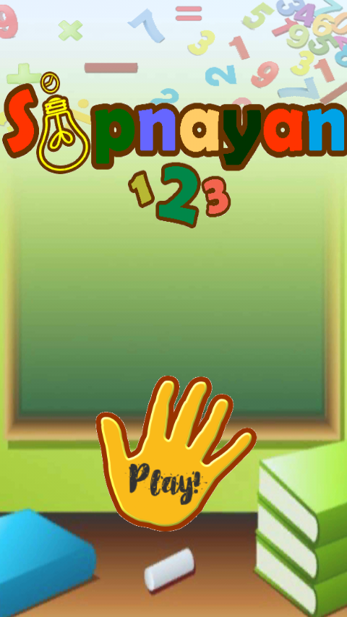

Figure 2.0 **Title Screen**

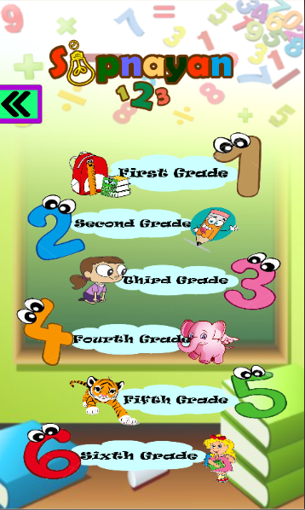

Figure 3.0**Main page**

This scene is the Main page where you can chose what grade level you want to view.

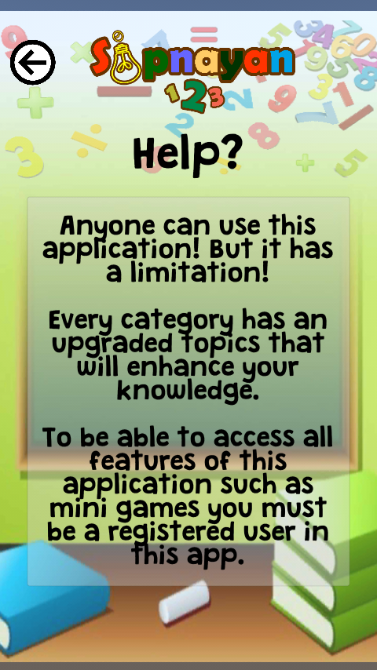

Figure 4.0**Help**

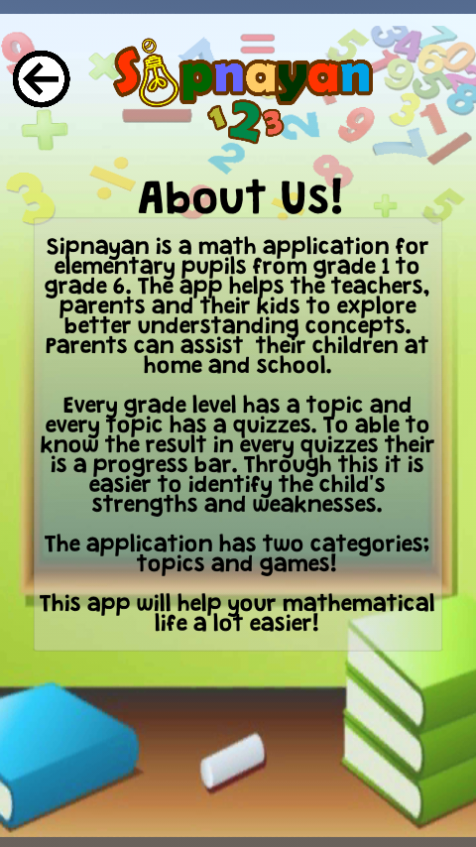

Figure 5.0**About us**

Sipnayan is a math application for elementary pupils from grade 1 to grade 6. The app helps the teachers, parents and their kids to explore better understanding concepts. Parents can assist their children at home and school.

Every grade level has a topic and every topic has a quizzes. To able to know the result in every quizzes their is a progress bar. Through this it is easier to identify the child's strengths and weaknesses.

The application has two categories; topics and games!

This app will help your mathematical life a lot easier!

Help!

Anyone can use this application! But it has a limitation!

Every category has an upgraded topics that will enhance your knowledge.

To be able to access all features of this application such as mini games you must be a registered user in this app.

**Design of System and Processes**

This section contains the Software Development Life Cycle, System Flowchart, Entity Relationship Diagram, Context Diagram, and Database tables.

The proponents used the Agile Model Methodologies for the Software Development Life Cycle. The proponents used Agile Model Methodologies to develop the Advanced learning mobile application in Mathematics. Agile SDLC model is a combination of iterative and incremental process models with focus on process adaptability and customer satisfaction by rapid delivery of working software product. Agile Methods break the product into small incremental builds. These builds are provided in iterations. Each iteration typically last from about one to three weeks.

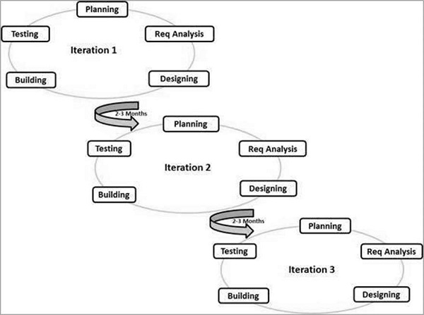

Figure 6.0**Agile SDLC**

Agile uses an adaptive approach where there is no detailed planning and there is clarity on future tasks only in respect of what features need to be developed. There is feature driven development and the team adapts to the changing product requirements dynamically. The product is tested very frequently, through the release iterations, minimizing the risk of any major failures in future.

*Concept –* Projects are envisioned and prioritized.

*Inception –* Team members are identified, funding is put in place, and initial environments and requirements are discussed.

*Iteration/Construction –* The development team works to deliver working software based on iteration requirements and feedback.

*Transition/Release –* QA (Quality Assurance) testing, internal and external training, documentation development, and final release of the iteration into production.

*Production –* Ongoing support of the software. With the successful completion of the transition phase the project falls into the final stage of production. This is basically the finalizing stage of the agile development cycle that leads to the final production of the project.

*Retirement –* End-of-life activities, including customer notification and migration. The final phase of the final implementation of the developed software or also called the retirement stage. This stage is re-fried as the retirement phase due to the final structure achievement of the stage leading to completion of the project and thereby release of the related developers.

**Entity Relationship Diagram**

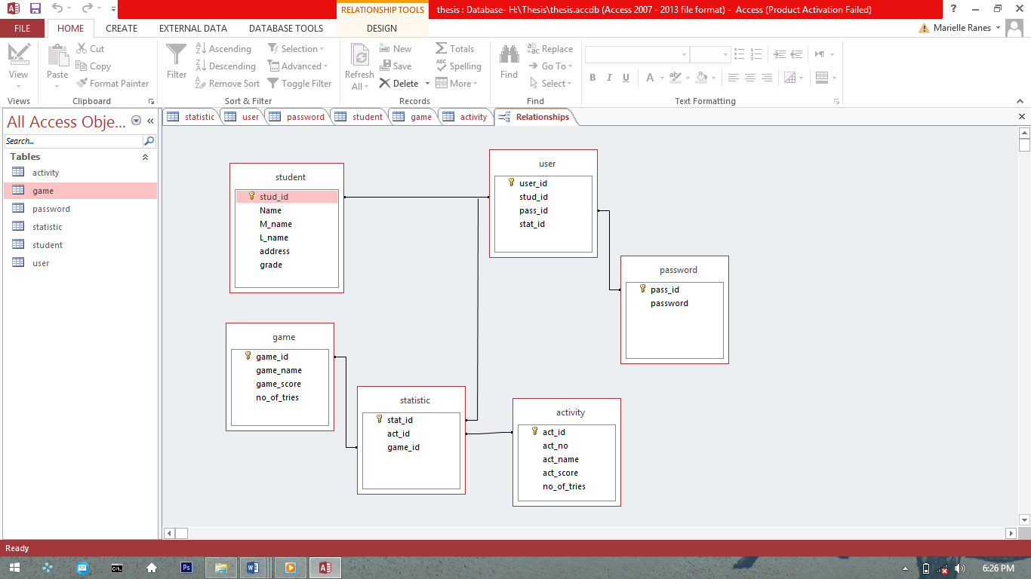

Figure 7.0**Entity Relationship Diagram**

Figure 8.0 shows the Entity Relationship Diagram of the Advanced Learning Mobile Application in Mathematics for Elementary Pupils. All connecting arrows mean one is to many relationships.

**Context Diagram**

This part of the chapter showed its context diagram below. Context diagram in software engineering & systems engineering is a diagram that defines the boundary between the system, or part of a system, and its environment, showing the entities that interact with it. This diagram is a high level view of a system.

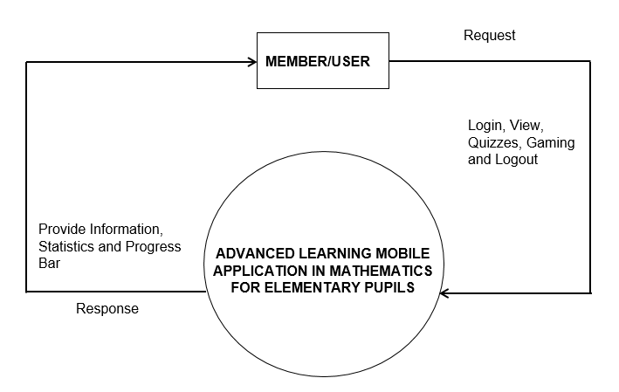

Figure 9.0 **Context Diagram**

**SYSTEM FLOWCHART**

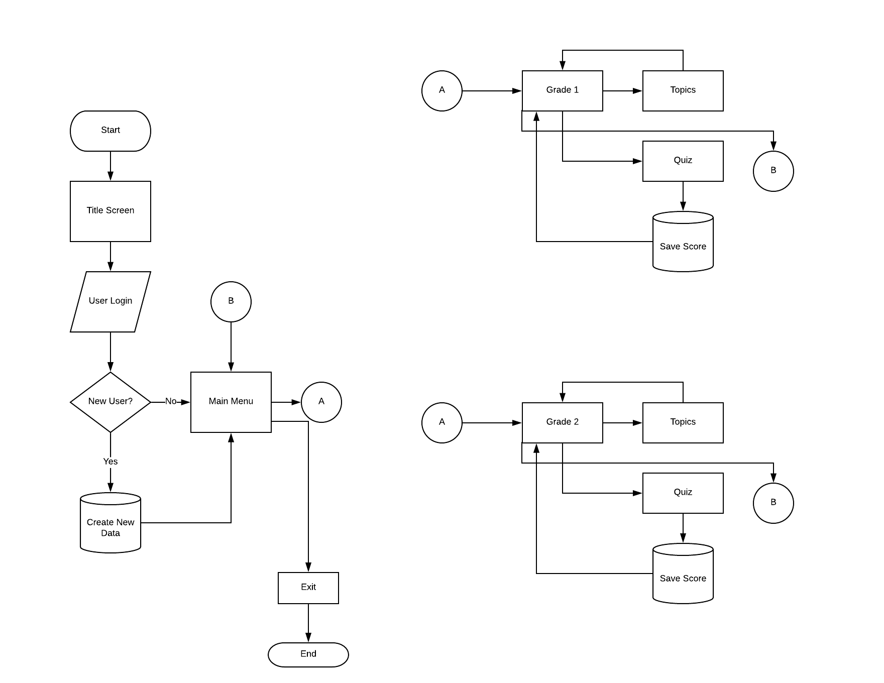



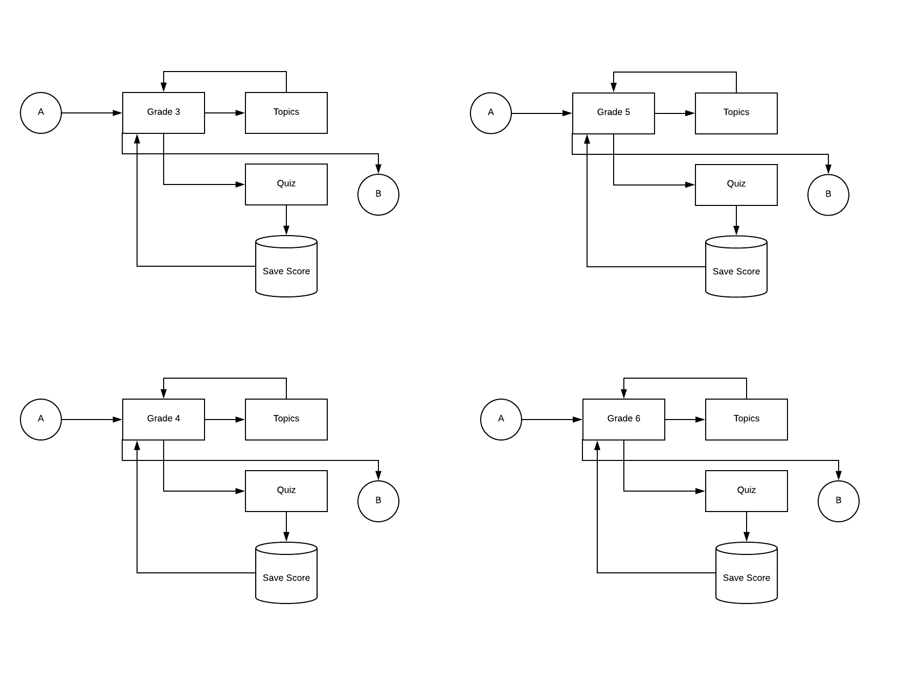



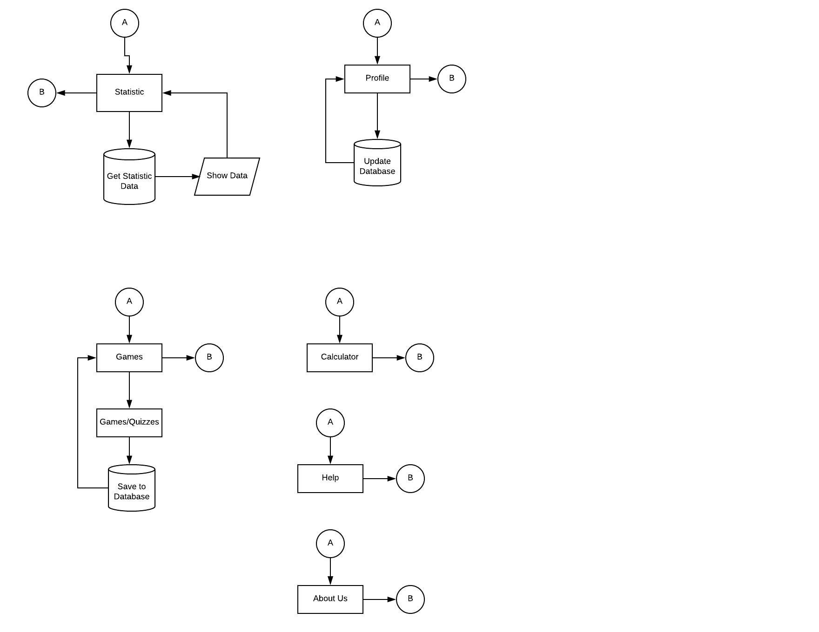





**Database Table**

|  |  |  |
| --- | --- | --- |
|  | Type | Schema |
| **Stats** |  | CREATE TABLE “Stats”(‘stats_id’ INTEGER NOT NULL UNIQUE, ‘quiz1’ INTEGER NOT NULL, ‘quiz2’ INTEGER NOT NULL, ‘quiz3’ INTEGER NOT NULL) |
| stats_id | INTEGER | ‘stats_id’ INTEGER NOT NULL UNIQUE |
| quiz1 | INTEGER | ‘quiz1’ INTEGER NOT NULL |
| quiz2 | INTEGER | ‘quiz2’ INTEGER NOT NULL |
| quiz3 | INTEGER | ‘quiz3’ INTEGER NOT NULL |

Table 1.0 **Statistics**

|  |  |  |
| --- | --- | --- |
|  | Type | Schema |
| **Users** |  | CREATE TABLE “Users”(‘user_id’ INTEGER NOT NULL PRIMARY KEY AUTOINCREMENT UNIQUE, ‘firstName’ TEXT NOT NULL, ‘middleName’ TEXT NOT NULL, ‘lastName’ TEXT NOT NULL) |
| user_id | INTEGER | ‘stats_id’ INTEGER NOT NULL UNIQUE |
| firstName | TEXT | ‘firstName’ TEXT NOT NULL |
| middleName | TEXT | ‘middleName’ TEXT NOT NULL |
| lastName | TEXT | ‘lastName’ TEXT NOT NULL |

Table1.1 **Users**